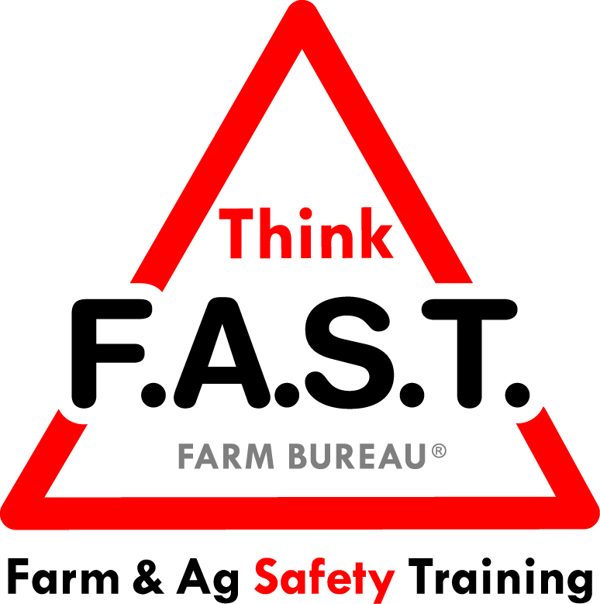

Module 7: Situational Management with Bins, Silos & Pits

Objectives:
- The learner will understand that our point of view and reaction can change depending on the conditions around us in our situation.
- The learner will demonstrate an understanding of the types of dangerous spaces in an agriculture environment.

Time Required:
- Approximately 40 minutes

Materials & Set-Up:
- Pen/paper – per individual
- 3 papers, labeled “Engulfment,” “Atmospheric,” and “Energy”
- Examples of dangerous spaces common to your region/area via photographs, an aerial map, or visiting a farm or ranch
  - NOTE: If on a farm/ranch for the training, do NOT enter these spaces or use for demonstration purposes

Lesson:

Introduction
- To engage youth, ask them to write down a sentence or two that describes a situation that they were in recently that didn’t go like they thought it would.
- Ask them how they felt with the unexpected result(s).
- Remind them that situational management prepares them for the unexpected, but that they must learn to recognize when the situation has made a task more challenging or dangerous than they are prepared to handle.
- Preview that today’s focus is on very dangers spaces in agriculture environments, such as bins, silos, and pits. Remind them that this training is NOT going to prepare them to enter these spaces; this is for their awareness and safety.

Suggested Skill Building Activities:
*Note: Instructor may modify for time and regionally-appropriate content, as long as safety and core skills are adequately addressed.

- Thumbs Up, Thumbs Down
  - Tell youth that they need to respond to the following scenarios with a “thumbs up” (good move) or “thumbs down” (bad move). Discuss the group results as appropriate.
    - You just got a new ATV, and want to take it out to show your friends. It has just started to rain.
    - You’re out on a run for cross country practice and you notice a dog running toward you with no leash. You stop and start yelling.
    - You have got to get your homework done tonight. Your phone keeps going off, so you pick it up and soon find that you’ve spent an hour doing nothing!

Core skill: We have to understand that our reactions and actions may change based on the conditions within our situation, and we need to respond appropriately and safely.
Indicators of activity success:
- Through active participation, learners are engaged in thoughtful responses to the situational management activity.

- Places & Spaces
  - Have youth point out or call out examples of dangerous spaces on a farm or ranch.
    - As they are named, ask participants to describe WHY it is a dangerous space
  - Remind youth that dangerous spaces may look different across the country. Ask them to name several spaces that they are aware of that may not be specific to their area.
    - If students have viewed the corresponding Think FAST online module, you could also refer to it, as well, for examples.
  - If on a farm or ranch for this module training, show areas that are categorized as spaces to avoid, and make sure to relay WHY they should be avoided.
    - NOTE: Do NOT provide working demonstrations or allow youth near the dangerous spaces

Core skill: Understanding that there are areas to avoid on farms and ranches, and they might look different based on the operation or area of the country.
Indicators of activity success:
- Through active participation with examples (NOT demonstrations), learners will understand dangerous spaces on a farm/ranch.

- The Dangers Within
  - Break up class into three groups. Give each group one paper labeled either “Engulfment,” “Atmospheric,” or “Energy”
  - Ask youth to write the definition of the danger and specific examples of places/spaces it could happen on their paper.
  - As groups are working, interact with them to provide guidance and feedback on their answers.
  - After completion, have groups share their definition and examples.

Core skill: We need to be aware of dangers within areas to avoid on a farm or ranch.
Indicators of activity success:
- Through active participation with examples (NOT demonstrations), learners will understand the dangers within areas to avoid on a farm/ranch.

Reflection Questions
- To close out the lesson, ask youth the following questions, and allow for individual or group discussion:
  - How can we learn to react more appropriately in situations that don’t go as planned?
  - What can you do to become more aware of dangerous spaces on your farm or work environment?

Challenge
- The next time that you see a dangerous space on a farm or ranch, think about the possible dangers. Don’t fool around with dangerous spaces on the farm/ranch. Speak up for your safety and the safety of others.

Additional Resources:
- http://extension.psu.edu/business/ag-safety/confined-spaces/flowing-grain/hazards-of-flowing-grain

